Art 1

- Open up your construction paper with your prints on it, lay it out horizontally
- Lay it upside down so you are looking at the blank inside of the folder
- Fold down a sample from both the rainbow roll AND off set. Glue down what you fold over…
  - Can be from the top
  - Can be from the bottom
  - Can be from the left and right
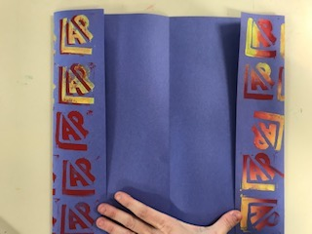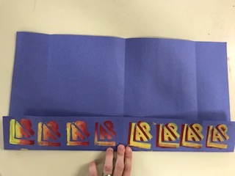

- Use a Sharpie (check this out from the teacher if you don’t have one) and write how you did these prints.
  - Explain how you did both of these processes as if you were telling a student who was not here for that class.
  - Make sure you label Rainbow Roll & Offset Print Use complete sentences
  - Check your spelling first!!
- Cut out the pictures/drawings of the tools from your printmaking notes.
- Glue them down on your construction paper and label what they are (or you can redraw them)
- Leave room for your reductive prints that we will do next class together
- Write your name on your work and turn this in for a grade
