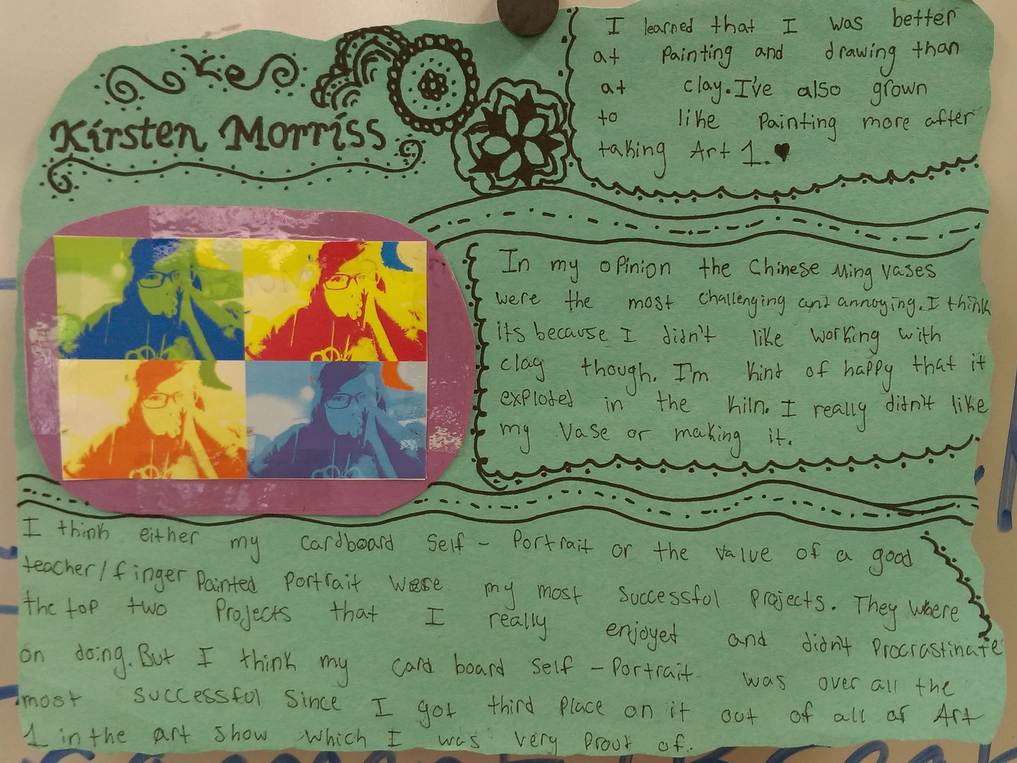

Art 1 Reflection/Final

Cut out and glue your Pop Art Self Portrait onto a piece of construction paper. Answer the following reflection questions around, under, above, next to... the photo. Include your name in the page layout. This may be used as an art display for next school year.

Answer the following questions thoughtfully, using complete sentences…

- Tell me something you learned about yourself after taking Art 1.
Are you better or worse at something that you were not aware of? Did you enjoy it less or more than you thought you would? Did you like or dislike working with a certain material (clay, paint, printing, cardboard)? What did you learn about how you like to work (are you a perfectionist, do you prefer a quiet vs noisy classroom, etc.)?

- What was the most challenging project you did throughout the whole year?
(woven animals, clay Chinese Ming vases, throwing on the wheel, plastic bag weaving, printmaking, Op Art drawing, Drawn Self-Portrait, Cardboard Self-Portrait, Drawing Vases, The Value of Good Teacher/Finger-Painted Portrait, Cubism Characters)
TELL ME WHY IT WAS CHALLENGING!

- What was your most successful project from the whole year, TELL ME WHY IT WAS SUCCESSFUL??

Assessment
All of the required components are there; Name, Pop Art photo, 3 answered questions in complete sentences
4 3 2 1

Composition: The words and photo are arranged in an aesthetically pleasing way. It looks balanced and complete.
4 3 2 1

Craftsmanship: The words are dark (not in pencil) and legible. The paper is clean and not torn. Overall the artwork looks clean and neat.
4 3 2 1

