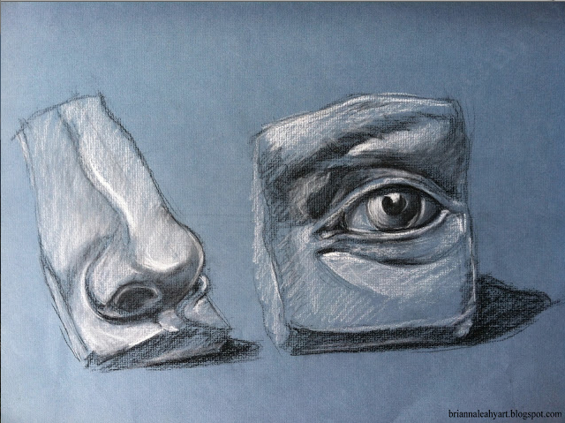

Art 1 FINAL- Clay Relief/ Facial Fracture

OBJECTIVE | ASSESSMENT 1 (low)-4 (high)
At least 2 facial features from the relief-cardboard sculpture have been created out of clay
Features are proportional to each other and are life-sized
There are different levels of relief (sunken-low and high) used throughout
Texture is used effectively (smooth on skin, hair on eyebrow and around ear for hair)
OPTIONAL: Painting with underglaze

STEP 1: Make choices! What two facial features will you use? Have those traced out on tracing paper. Cut the tracing paper as a pottery shard/broken piece of ceramic.
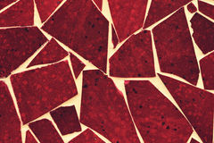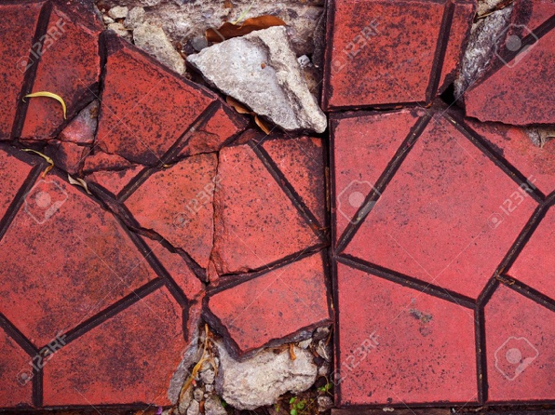
Bring your tracing paper cut out to the teacher to get your slab of clay

STEP 2: Pick up your slab and drop it on the table a couple of times to create a more organic shape

STEP 3: Put your tracing paper over your slab and retrace your facial features, pushing the lines into the clay.

STEP 4: Begin creating different levels of relief- what needs to go back for sunken relief, what needs to raise up for low relief, what would stick out the farthest for high relief?

How do you add clay to create high relief?
- Create the shape out of new clay that you want added
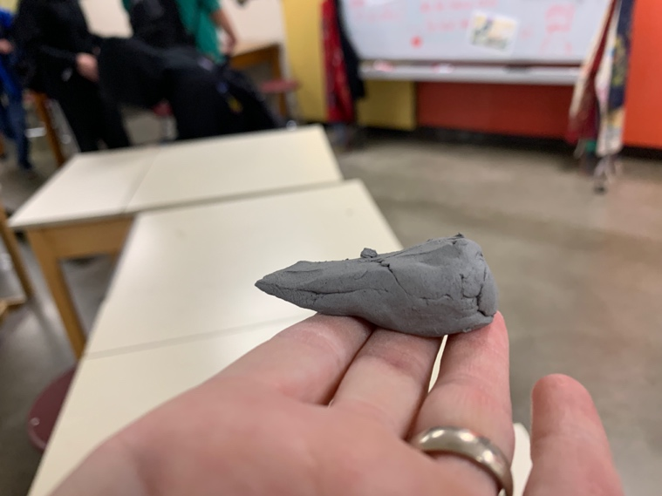
- Slip and score on the back side and where you want the piece added
- Smoosh and smooth it together

STEP 5: Use different tools to create different effects; undercut (ex: scraping clay out from inside the nostril), scraping for texture, sponge for smoothing
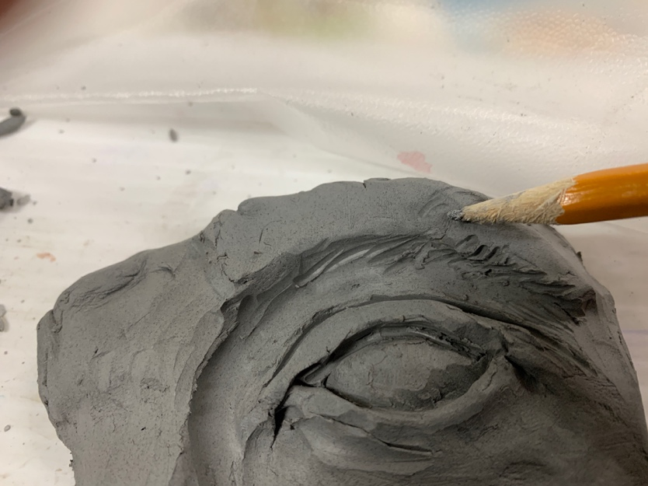
Use a pencil to draw in any hair/texture lines. Be intentional with the direction of your marks!

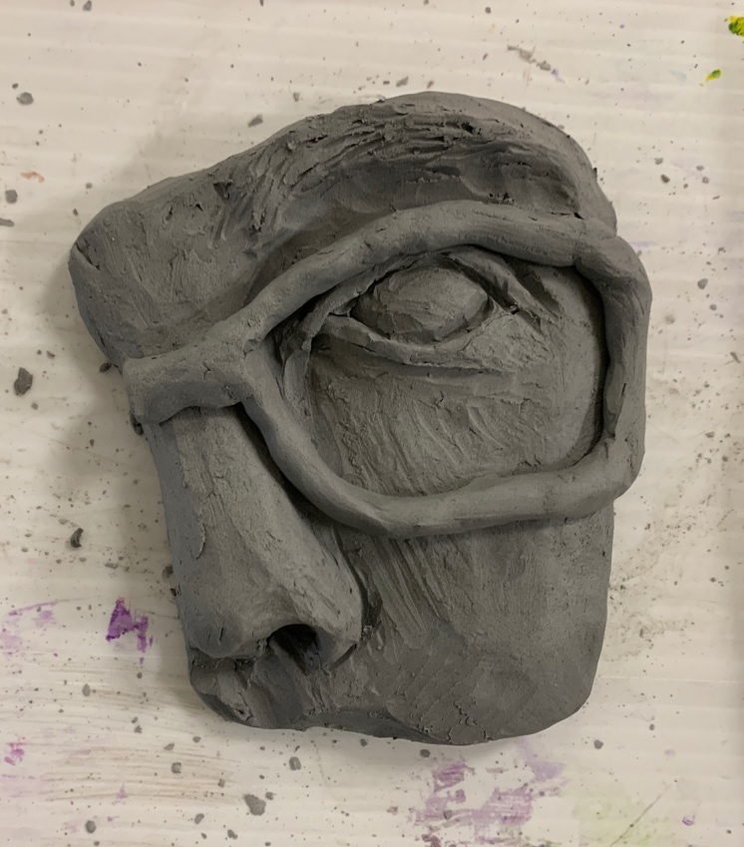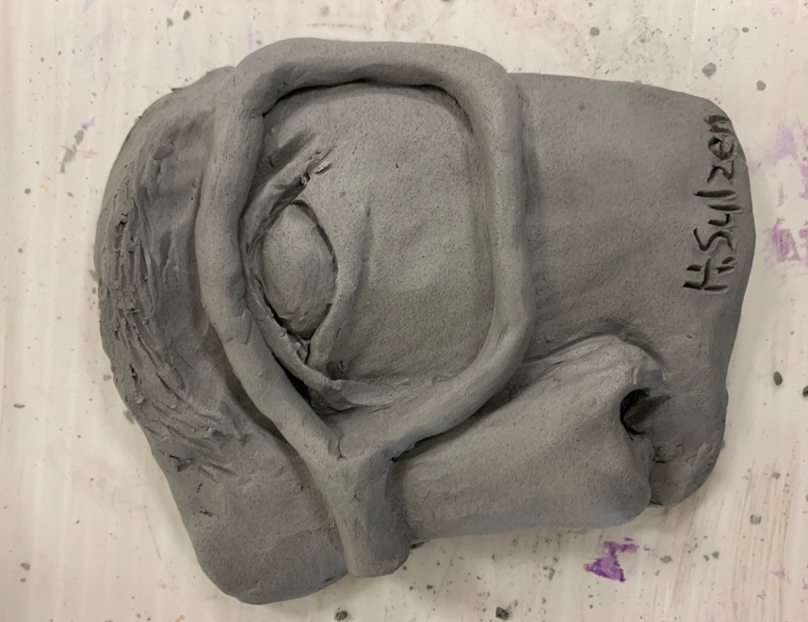
What tools can you use to smooth out the texture of the clay?

OPTIONAL: Painting with underglaze
