ART 1, 2019-20
Project Art History & Examples Materials and Objectives
- Assemble Sketchbooks
- OP ART; Black & White Unit  Notes | OP Art
- Geometric Animals  - Select an animal to draw  - Break up the animal into GEOMETRIC SHAPES  - Photocopy and collage drawings from Op Art Notes and/or Op Art handout-examples  - Color may be added in one area for EMPHASIS  - Discuss different patterns being used for dif. VALUES  - Discuss overall unity, repetition, movement and contrast | 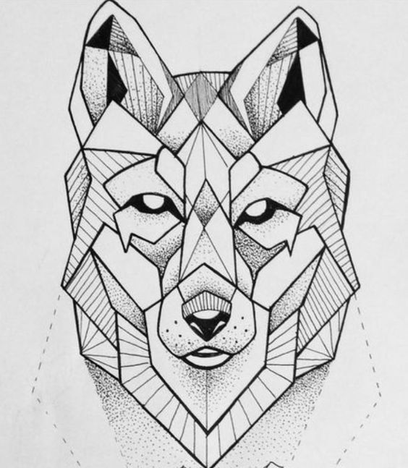 | - Op Art notes from Sketchbook OR printed handouts of examples  - Tracing paper  - Pencils  - Rulers  - Drawing paper  - Glue  - Sharpie markers
- Drawing Forms | 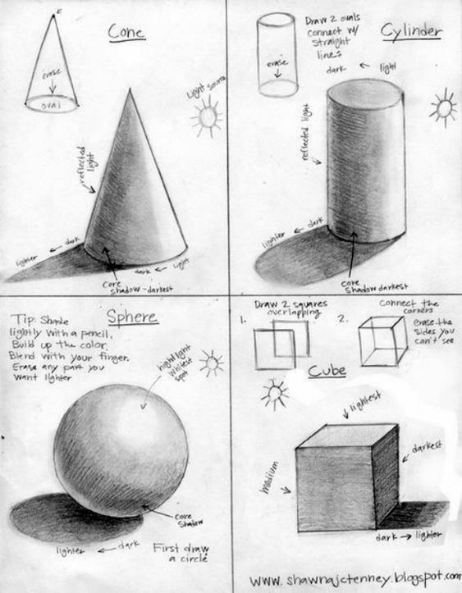
- Drawn Self-Portrait | 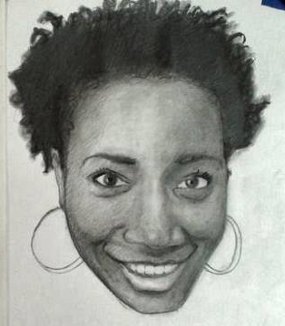
- Cardboard Self-Portrait | 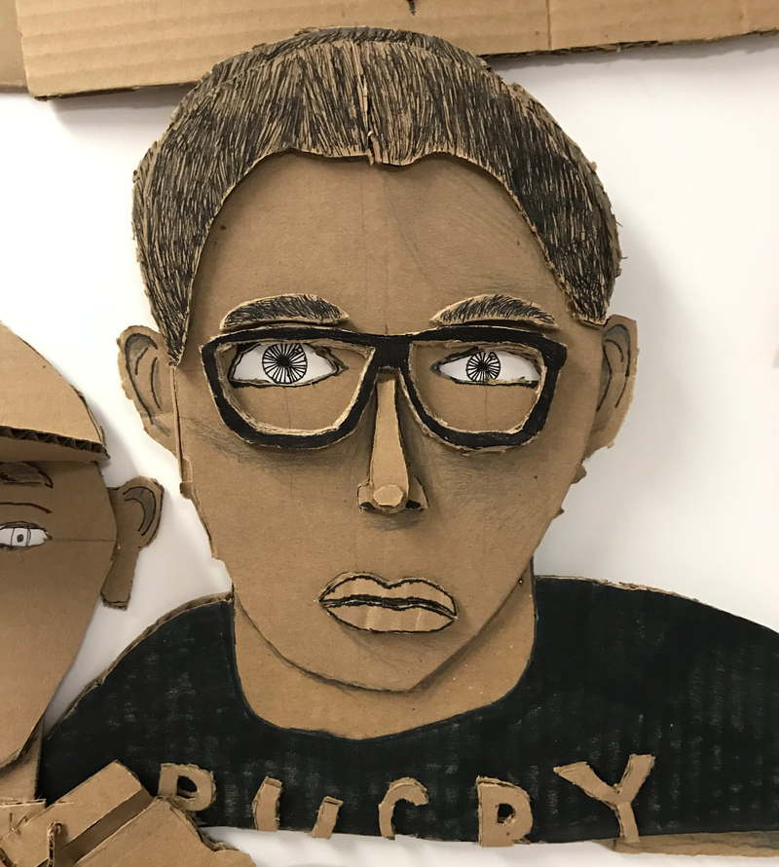
PRINTMAKING; Self-Portrait  - Take photo of student  - Grid photo & Bristol paper, enlarge  - Create two relief carvings of tessellations, front and back of block  - Draw self portrait  - Print one side of block onto construction paper for hair and clothes  - Paint a flat solid color for face  Outline shapes and features w/marker | - Pop Art  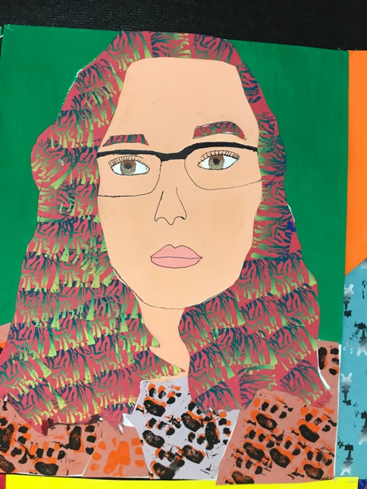 | - 3”x3” rubber blocks  - Carving tools  - Tracing paper  - Drawing paper  - Construction paper  - Thin markers  - Tempera paint  Colored pencils (maybe)  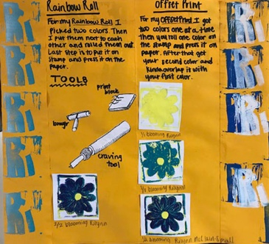
Maria Martinez
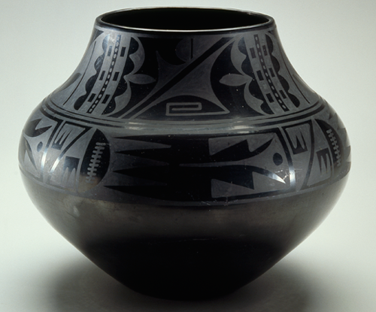

Collaborative Class Weaving/paint
PAINTING; watch Loving Vincent  - Van Gogh coloring sheet OR tint and shade flower sheet  - Notes on Impressionism & Post  - Choose an artwork to reproduce  - Draw grid on Bristol paper  - Use white roll paper to match colors  - Must…  - Tint & shade  - Change intensity  - Add texture  Recreate the painting by ripping/cutting and collaging the painted papers | Impressionism & Post  - Van Gogh  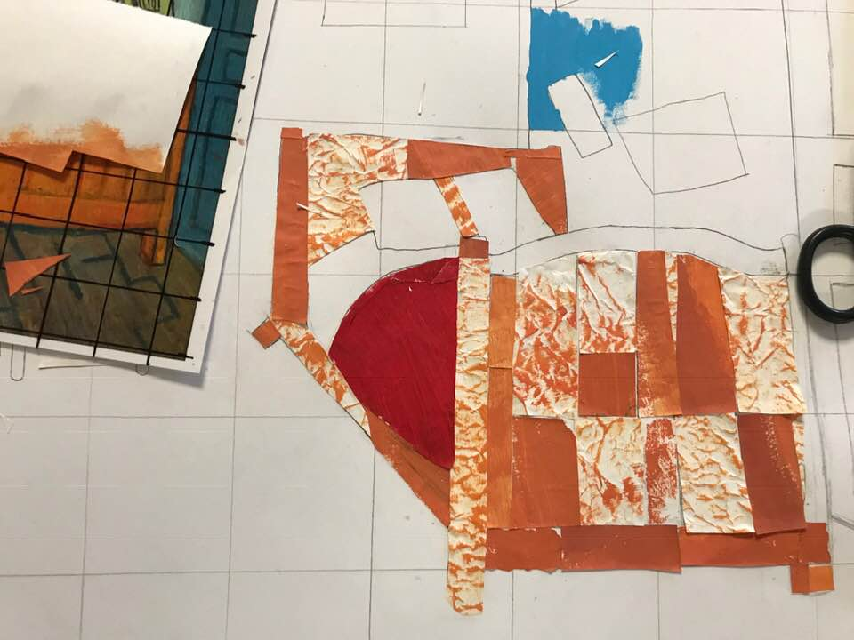 | - White roll paper  - Texture tools for paint  - Tempera paint  - Bristol paper  TEXTURES  - Bubble wrap  Sponges
 | 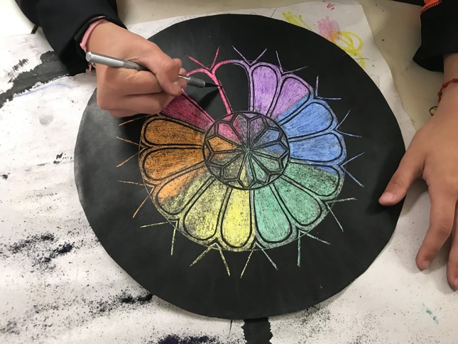
Perspective | 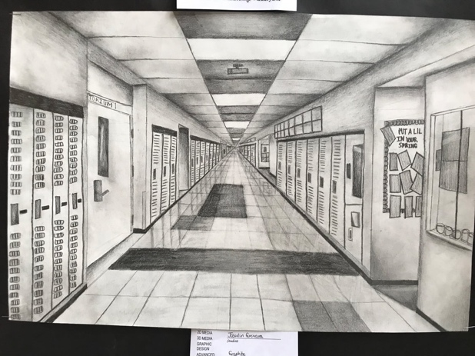  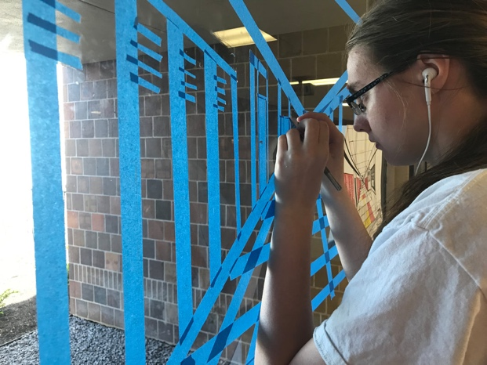
Autobiographical Comic

