2D: I can use color to shade and tint a Still-Life Painting
Why: Before we create a complex painting, we need to transfer what we learned about layering colors to create new colors from colored pencils into paint.

Step 1: Select two small photographs of white objects. Glue them into your sketchbook and redraw them.
To redraw them, I drew lines breaking the compositions in half on the photos to help align everything.
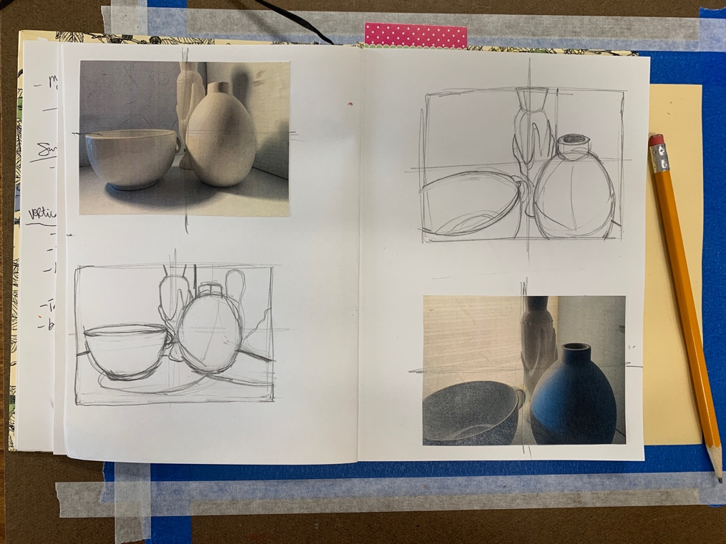

Step 2: Color in the thumbnail drawings using colored pencils. You need to LAYER colors together to get different tones of colors. How can you get black without using black? Where are the COOL shadows and where are the WARM highlights?
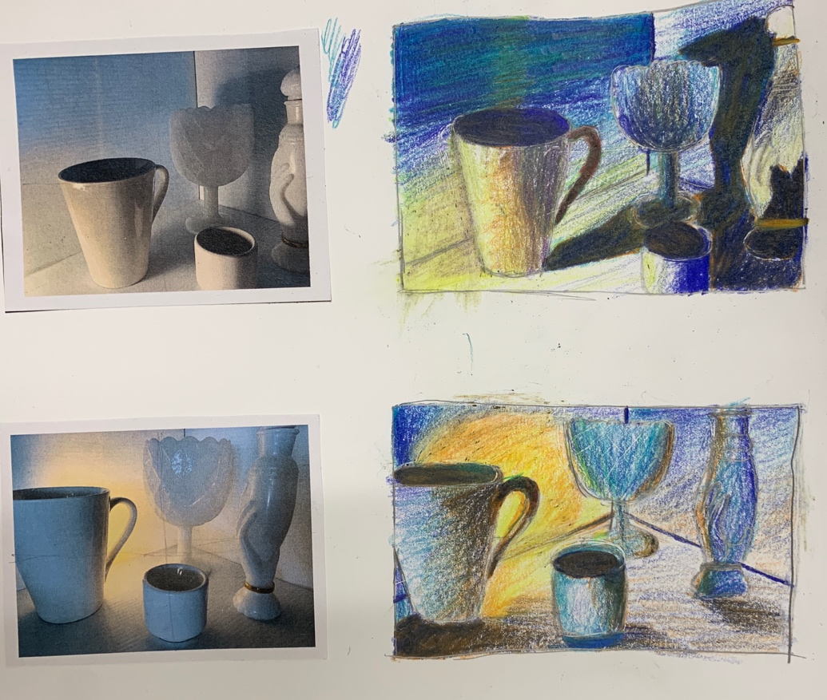
Step 3: Select the thumbnail drawing that is the most dynamic (does it have contrast, diagonal lines, objects going off the edge?). Tape down a cream piece of paper onto a board. Redraw your composition. (You can divide this drawing in half again if it helps draw out your shapes.)
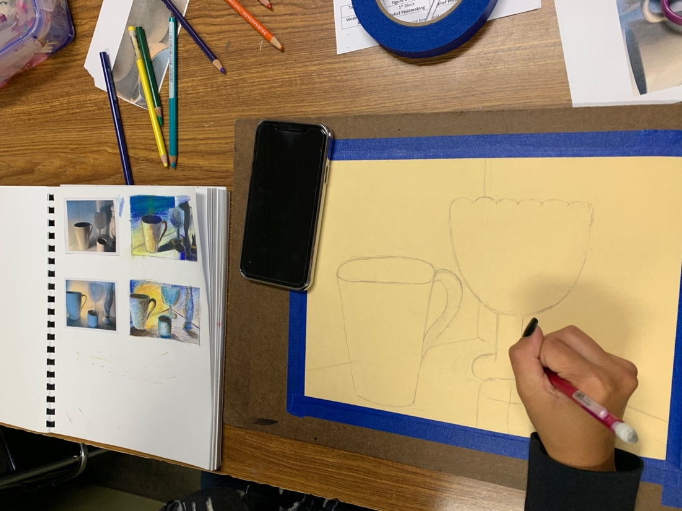

Step 4: Get a paint palette and your colors in tempera paint: white, yellow, red, blue and brown. Look at your drawing and find where the purest white highlights are- paint those onto your paper first; white highlights.

Step 5: Start mixing your colors to create secondary colors, dull the intensity (adding the complimentary color) and shading colors with other/darker colors by creating value scales. Do this practice in your sketchbook.
